Q1. What is a probability distribution, exactly? If the values are meant to be random, how can you predict them at all?

A probability distribution is a list of all of the possible outcomes of a random variable, along with its corresponding probability values.

A probability distribution describes how a random variable is distributed.It tells us which values a random variable is most likely to take on and which values are less likely. Based on the previous data and the occurences of the random event, we can predict the outcome in terms of probabilities

Q2. Is there a distinction between true random numbers and pseudo-random numbers, if there is one? Why are the latter considered “good enough”?

The methods commonly used to generate random numbers are not random processes. Random numbers are called psuedo-random numbers when they are generated by some deterministic process but they qualify the predetermined statistical test for randomness. The sequence of numbers generated by such process is completely determined by the input data (or the first random number) used for the method. True Random Numbers are true physical values while pseudo-random numbers are generated internally by a program . Latter is considered good enough as they have sort of uniform distribution.

Q3. What are the two main factors that influence the behaviour of a "normal" probability distribution?

The two main parameters of a (normal) distribution are the mean and standard deviation.

Q4. Provide a real-life example of a normal distribution.

Height of the population is the example of normal distribution. Most of the people in a specific population are of average height. The number of people taller and shorter than the average height people is almost equal, and a very small number of people are either extremely tall or extremely short. However, height is not a single characteristic, several genetic and environmental factors influence height. Therefore, it follows the normal distribution.

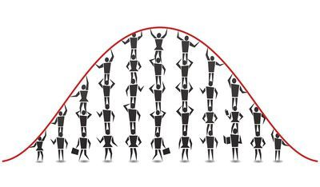

Q5. In the short term, how can you expect a probability distribution to behave? What do you think will happen as the number of trials grows?

Variance will decrease with number of trials

Q6. What kind of object can be shuffled by using random.shuffle?

lists (list), strings (str) and tuples (tuple) objects can be shuffled by using random.shuffle.

Q7. Describe the math package's general categories of functions.

The Math package's general categories of functions are:

1. Trigonometric functions
2. Quadratic functions
3. Exponential functions
4. Hyperbolic functions
5. Periodic functions
6. Arithmetic functions
7. Logarithimic functions
8. Conversions to Integer

Q8. What is the relationship between exponentiation and logarithms?

The logarithmic functions are the inverses of the exponential functions

Q9. What are the three logarithmic functions that Python supports?

The Three Logarithmic Functions that Python supports are:

1. log2(x) - logarithmic value of x to base 2
2. log10(x) - logarithmic value of x to base 10
3. log1p(a) - This function is used to compute logarithm(1+a) .